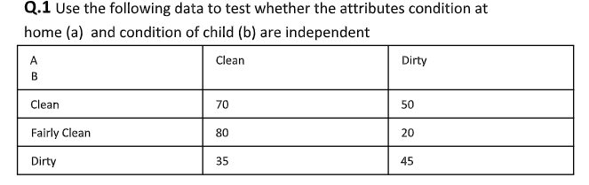
CODE :
x=c(70,50,80,20,35,45)
y=matrix(x,nrow=3,ncol=2)
y
chi=chisq.test(y,correct=FALSE)
chi
chi$expected
chi$observed
#pvalue<los; We reject H0.
OUPUT:
> x=c(70,50,80,20,35,45)
> y=matrix(x,nrow=3,ncol=2)
> y
[,1] [,2]
[1,] 70 20
[2,] 50 35
[3,] 80 45
> chi=chisq.test(y,correct=FALSE)
> chi

Pearson's Chi-squared test

data: y
X-squared = 7.7529, df = 2, p-value = 0.02072

> chi$expected
[,1] [,2]
[1,] 60.00000 30.00000
[2,] 56.66667 28.33333
[3,] 83.33333 41.66667
> chi$observed
[,1] [,2]
[1,] 70 20
[2,] 50 35
[3,] 80 45
> #pvalue<los; We reject H0.
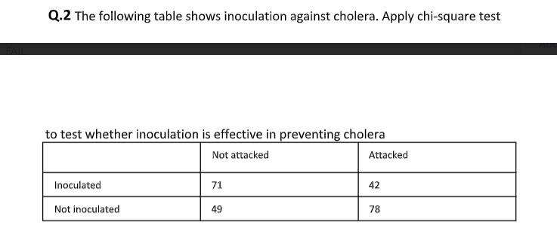
CODE:
x=c(71,42,49,78)
y=matrix(x,nrow=2,ncol=2)
y
chi=chisq.test(y,correct=FALSE)
chi
chi$expected
chi$observed
#pvalue<los; We reject H0.
OUTPUT:
> x=c(71,42,49,78)
> y=matrix(x,nrow=2,ncol=2)
> y
[,1] [,2]
[1,] 71 49
[2,] 42 78
> chi=chisq.test(y,correct=FALSE)
> chi

Pearson's Chi-squared test

data: y
X-squared = 14.065, df = 1, p-value = 0.0001766

> chi$expected
[,1] [,2]
[1,] 56.5 63.5
[2,] 56.5 63.5
> chi$observed
[,1] [,2]
[1,] 71 49
[2,] 42 78
> #pvalue<los; We reject H0.

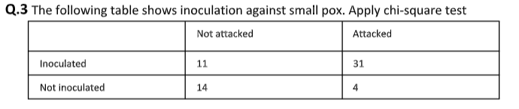
CODE :
x=c(11,31,14,4)
y=matrix(x,nrow=2,ncol=2)
y
chi=chisq.test(y,correct=TRUE)
chi
chi$expected
chi$observed
#pvalue<los; We reject H0.
OUTPUT:
> x=c(11,31,14,4)
> y=matrix(x,nrow=2,ncol=2)
> y
[,1] [,2]
[1,] 11 14
[2,] 31 4
> chi=chisq.test(y,correct=TRUE)
> chi

Pearson's Chi-squared test with Yates' continuity correction

data: y
X-squared = 11.755, df = 1, p-value = 0.0006068

> chi$expected
[,1] [,2]
[1,] 17.5 7.5
[2,] 24.5 10.5
> chi$observed
[,1] [,2]
[1,] 11 14
[2,] 31 4
> #pvalue<los; We reject H0.
>

– IS THERE IS ANY SIGNIFICANE OF FOOD PREFERENCE ON GENDER –
CODE:
data=read.csv(file.choose())
head(data)
Gender=data$Gender
FP=data$FOOD
Result=data$RESULT
table(Gender,FP)
chi=chisq.test(Gender,FP,correct=FALSE)
chi
chi$expected
chi$observed
OUPUT:
> data=read.csv(file.choose())
> head(data)
Gender FOOD RESULT
1 M HOMELY PASS
2 F OUTSIDE PASS
3 F HOMELY PASS
4 F HOMELY FAIL
5 F OUTSIDE FAIL
6 M OUTSIDE PASS
> Gender=data$Gender
> FP=data$FOOD
> Result=data$RESULT
> table(Gender,FP)
FP
Gender HOMELY OUTSIDE
F 11 7
M 9 13
> chi=chisq.test(Gender,FP,correct=FALSE)
> chi

Pearson's Chi-squared test

data: Gender and FP
X-squared = 1.6162, df = 1, p-value = 0.2036

> chi$expected
FP
Gender HOMELY OUTSIDE
F 9 9
M 11 11
> chi$observed
FP
Gender HOMELY OUTSIDE
F 11 7
M 9 13
>

